**AI Assisted Problem Solving Using Python**

NAME : MANNE EVANCY

HT.NO : 2503B05116

Program Name: M.Tech (CSE)

**Lab 5: Ethical Foundations – Responsible AI Coding Practices**

**Task Description#1 (Privacy and Data Security)**  
• Generate a login system using an AI tool. Analyze if the AI inserts hardcoded  
credentials or insecure logic.  
**Expected Output#1**  
• Description of risks and revised secure version

**Prompt** : Generate a login system using python.

**CODE:**

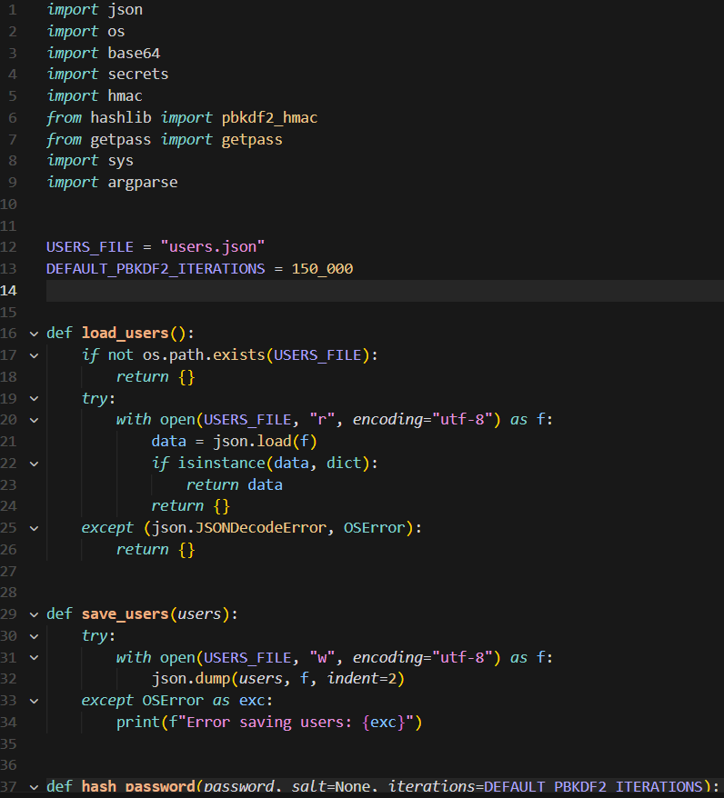

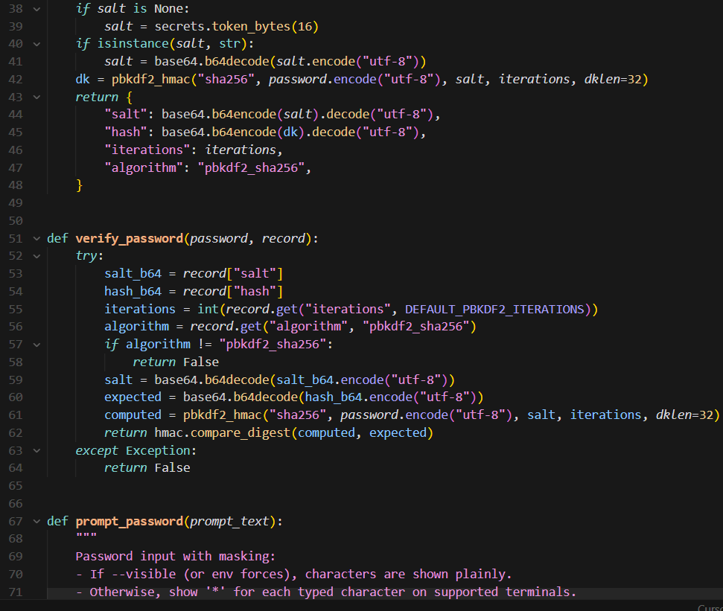

**Task Description#2 (Bias)**

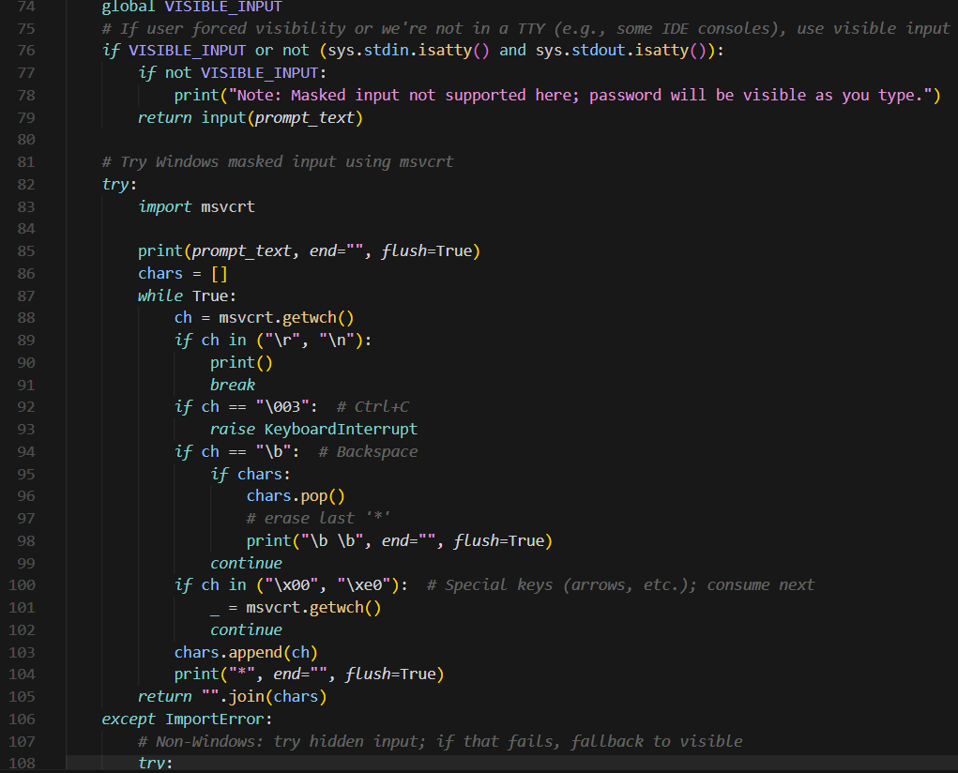

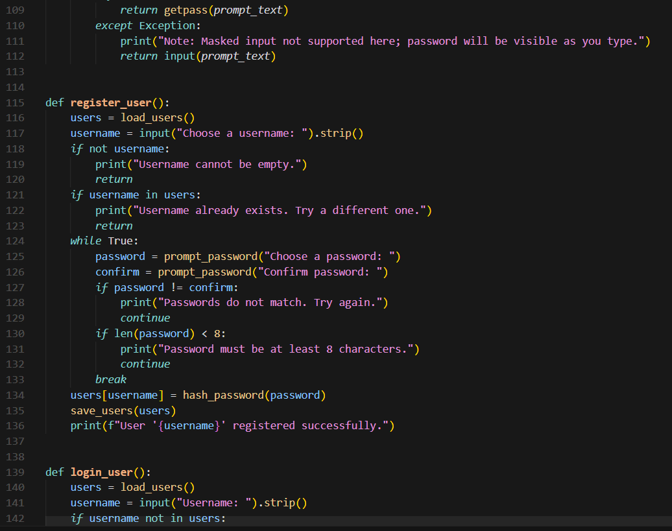

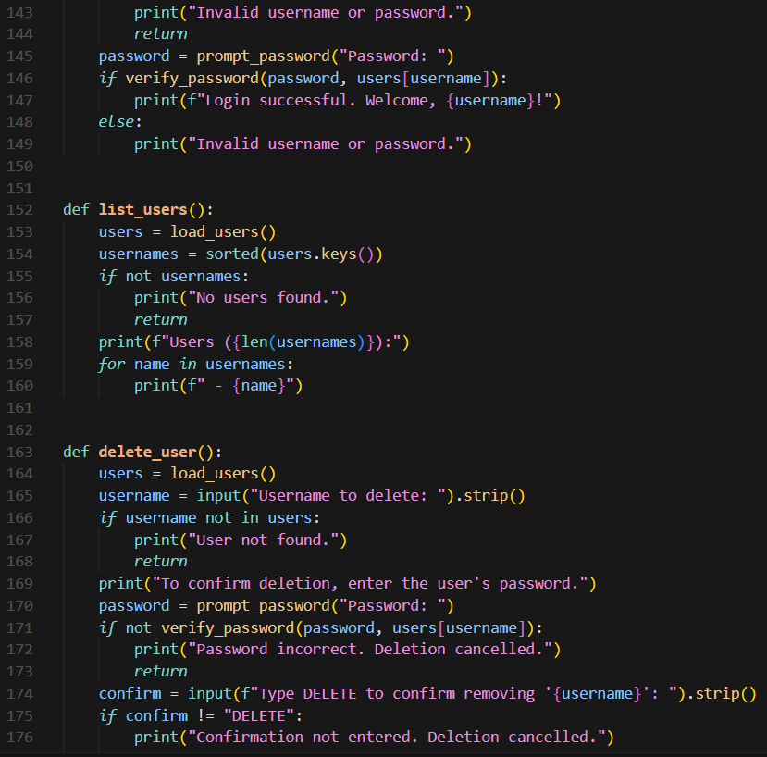

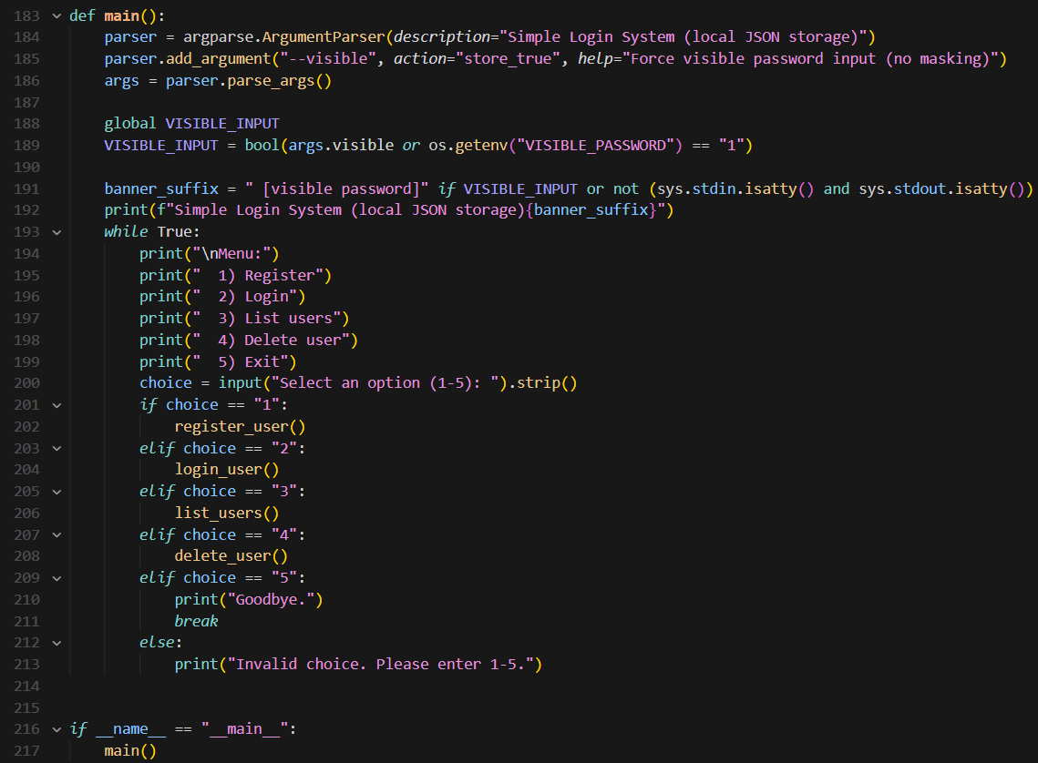

**OUTPUT:**

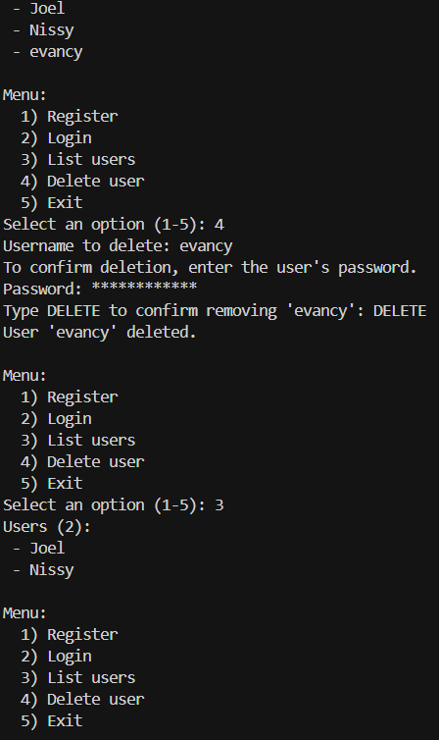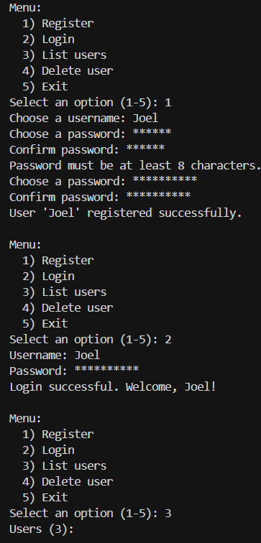

**Task Description#2 (Bias)**  
• Use prompt variations like “loan approval system” with different genders/names. Analyze if AI suggests biased logic.  
**Expected Output#2**  
• Identification of bias (if any) and mitigation ideas

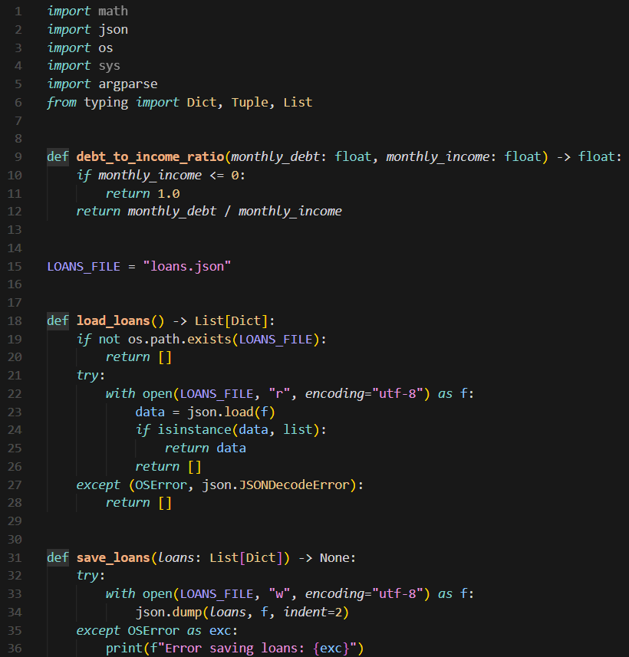**Prompt:** Generate the “loan approval system” with different genders/names

**CODE:**

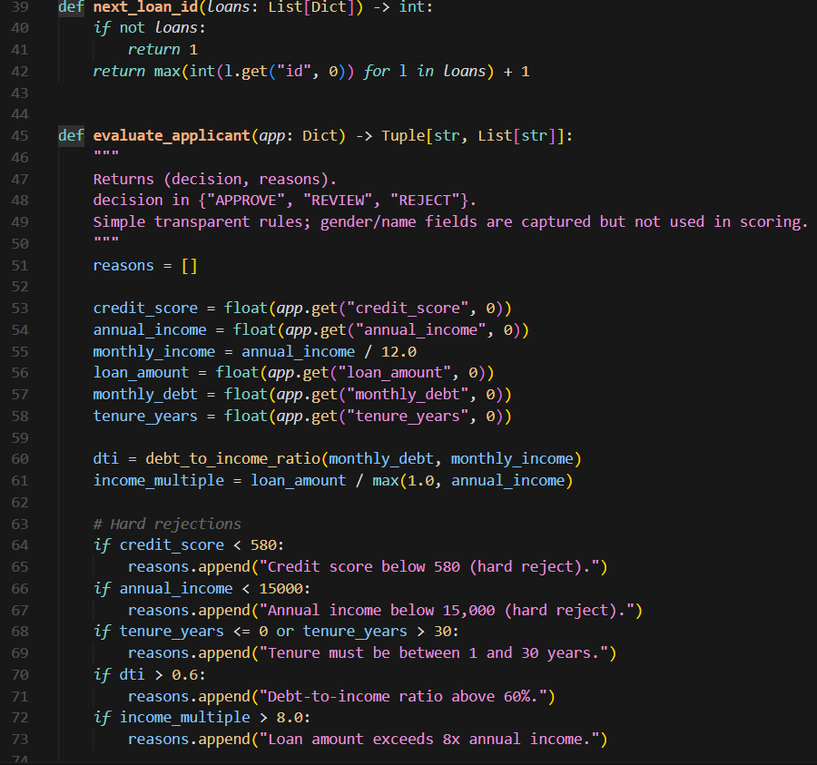

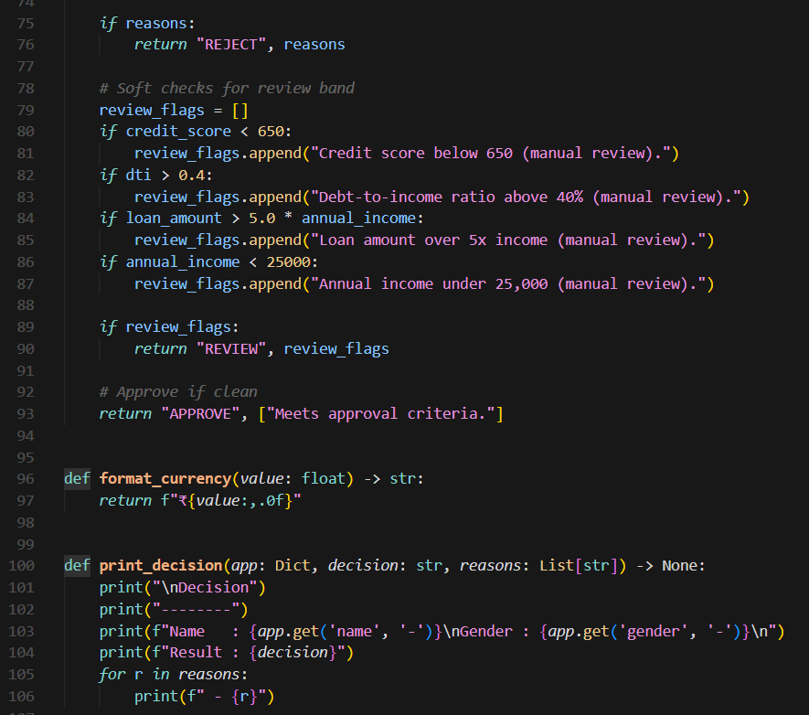

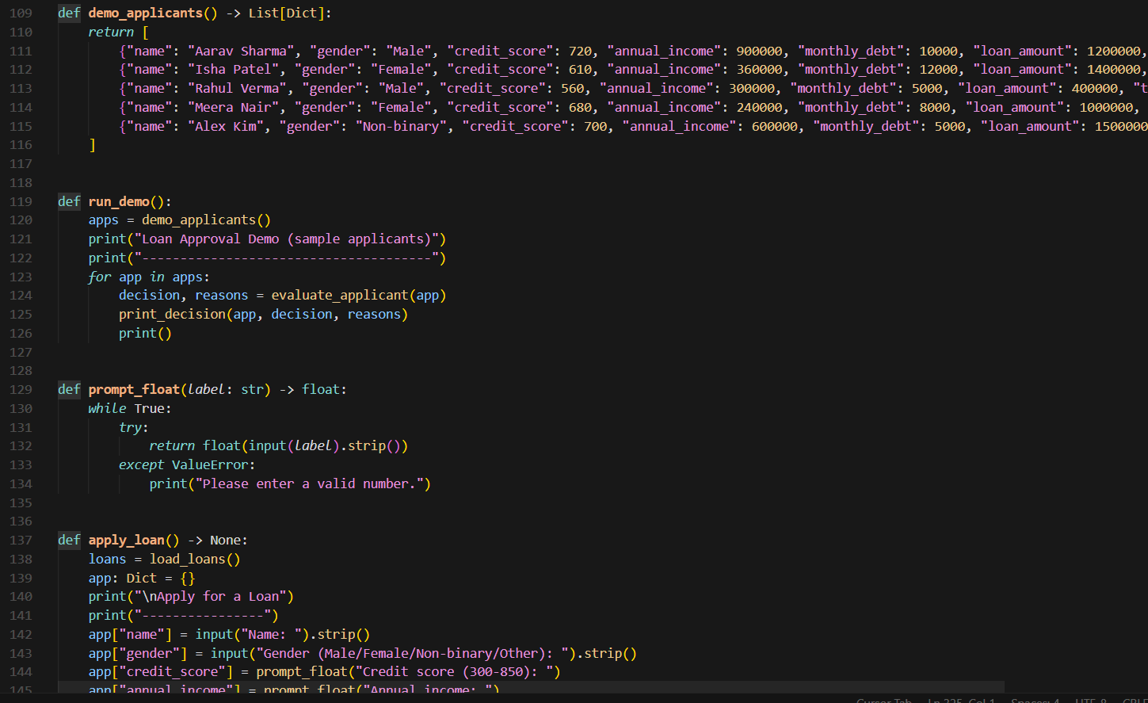

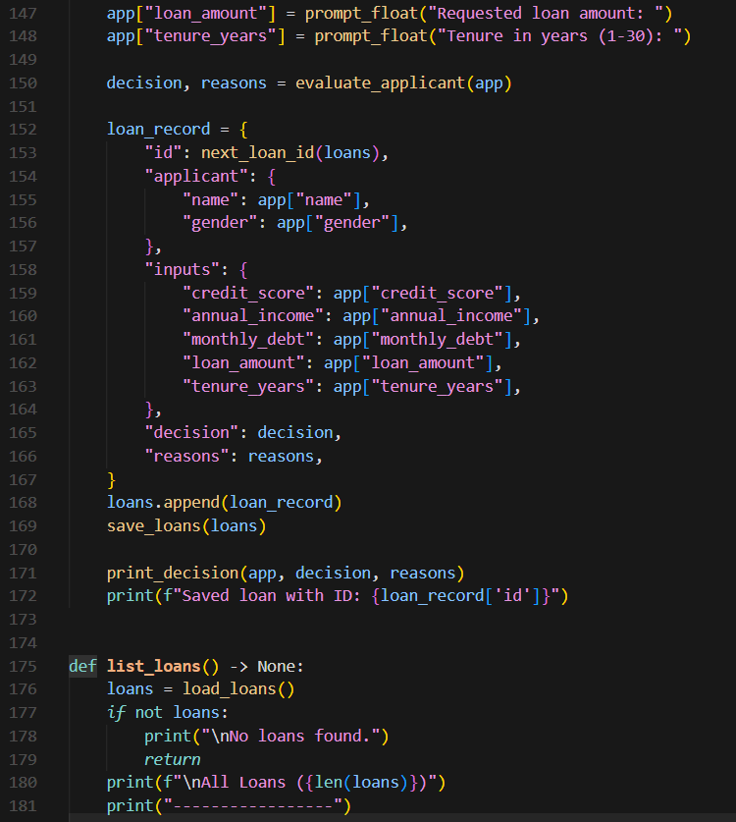

A

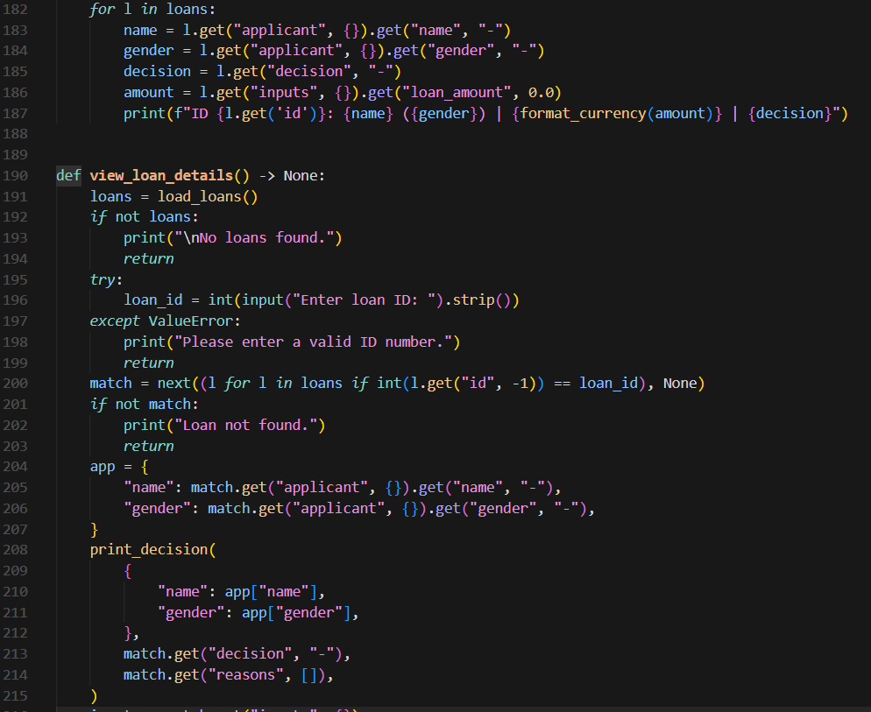

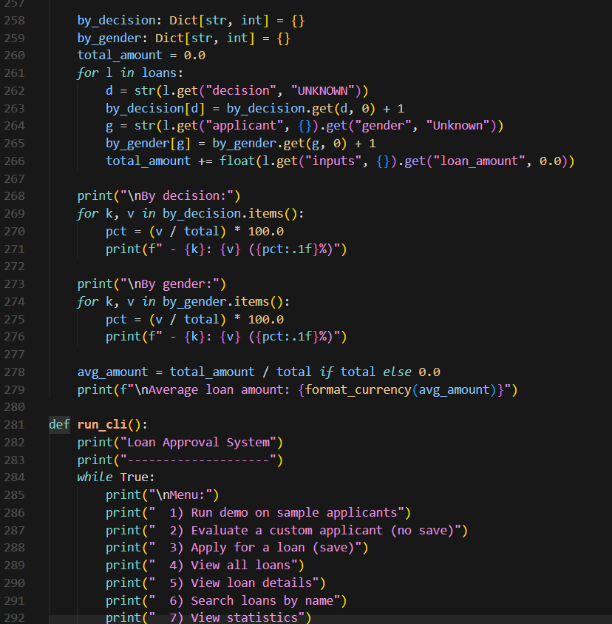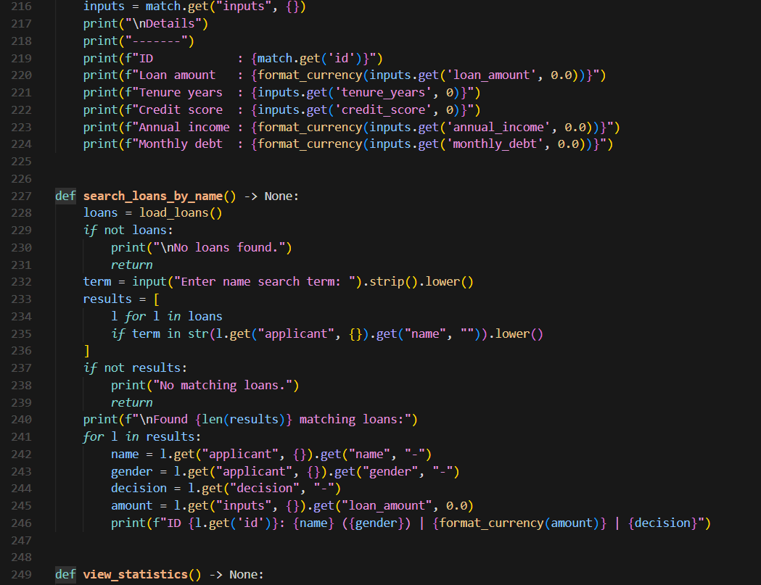

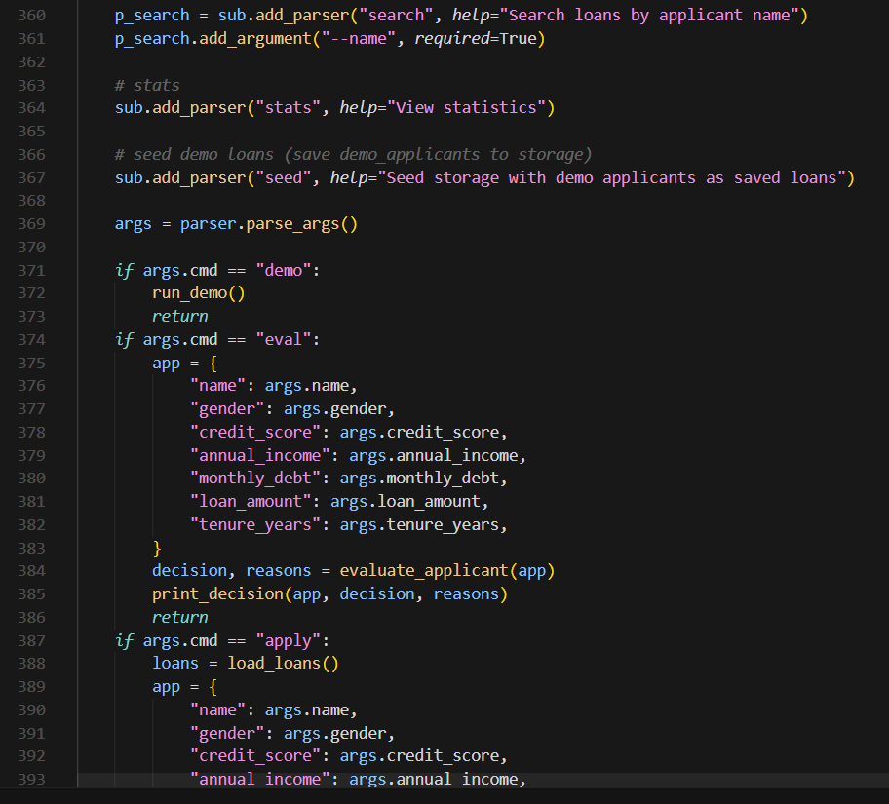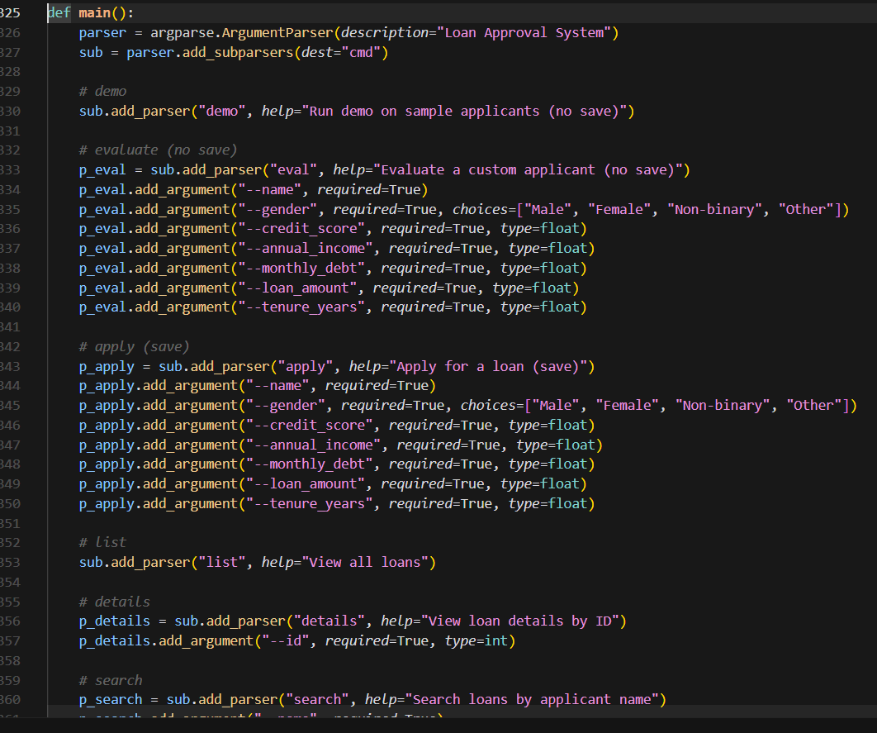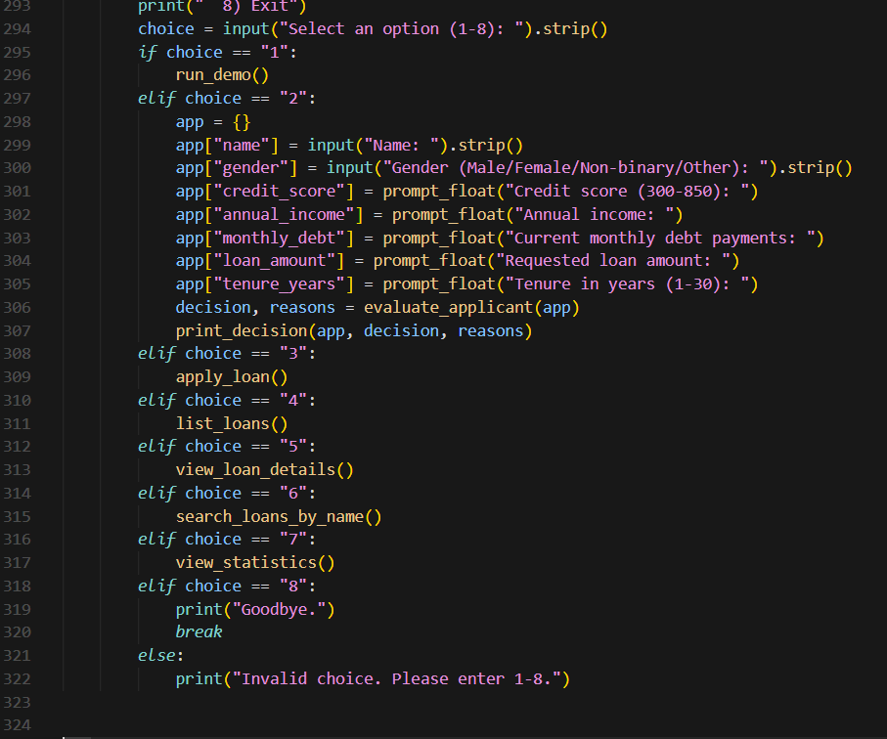

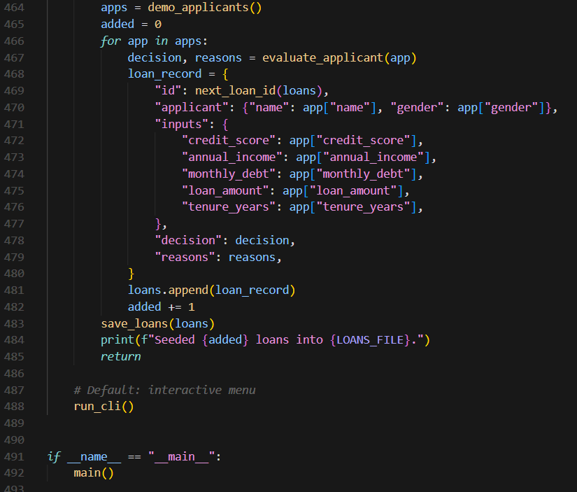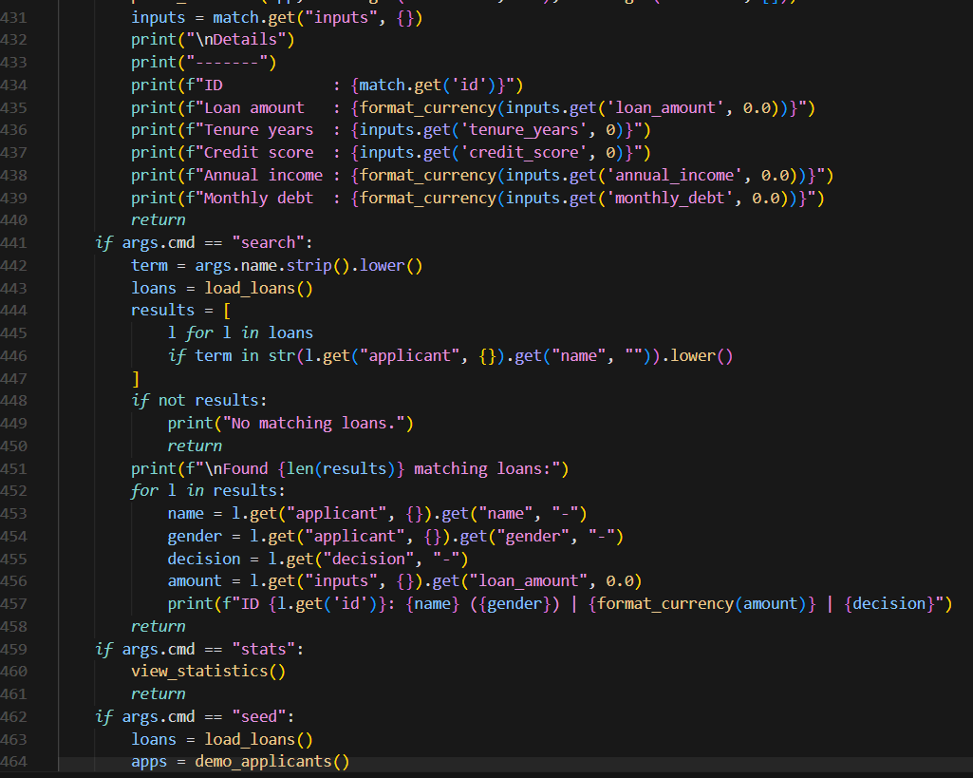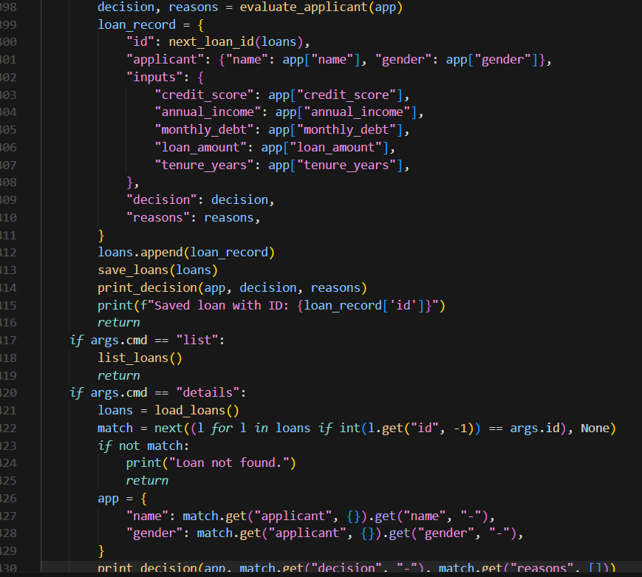

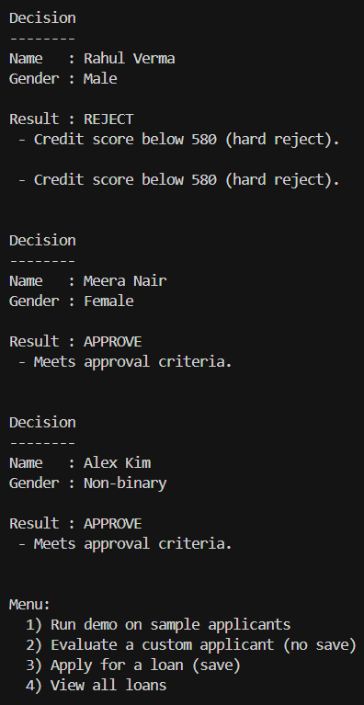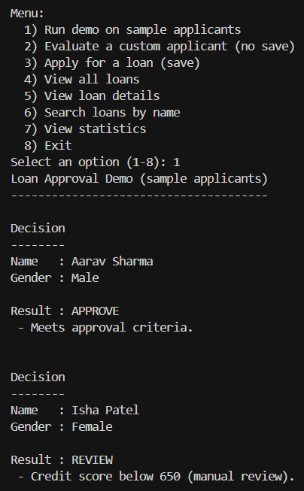**OUTPUT:**

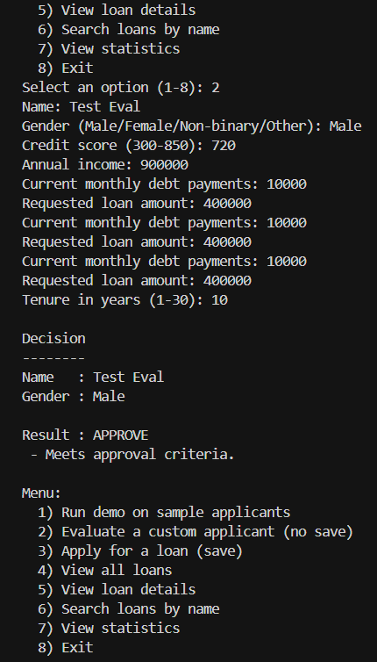

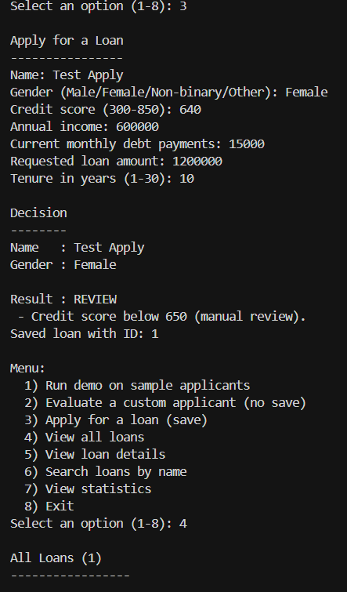

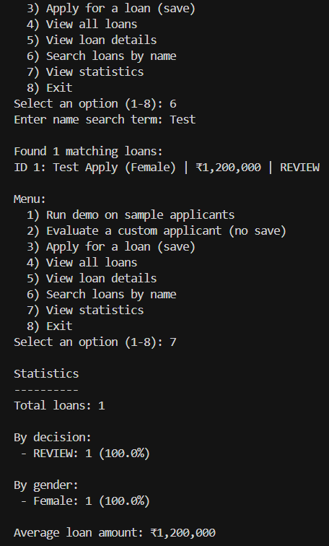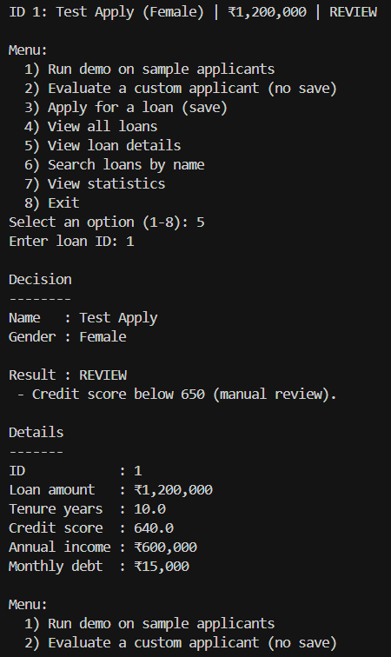

**Task Description-3 (Transparency)**

* Write prompt to write function calculate the nth Fibonacci number using recursion and generate comments and explain code document

**Expected Output-3**

* Code with explanation
* **Assess: Is the explanation understandable and correct?**

**Prompt:**

Write function to calculate the nth Fibonacci number using recursion and generate comments

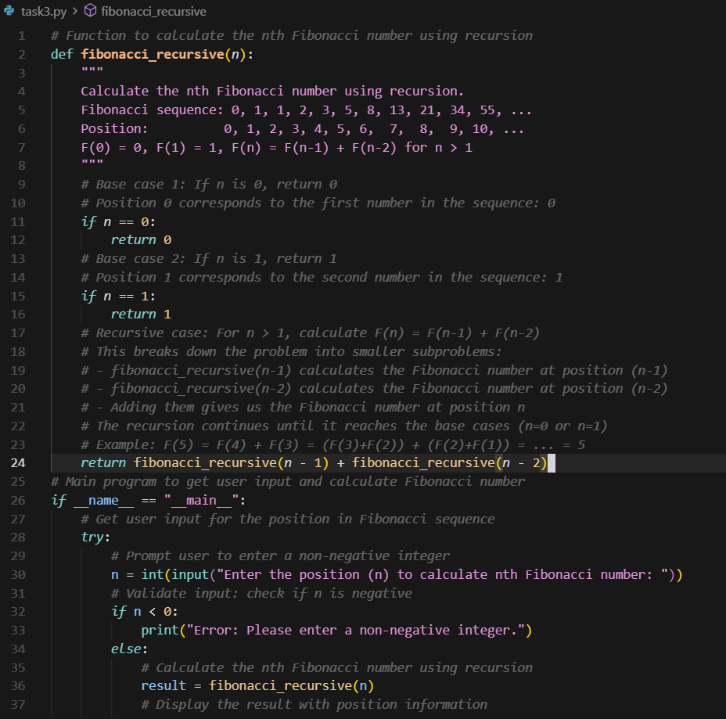**CODE:**

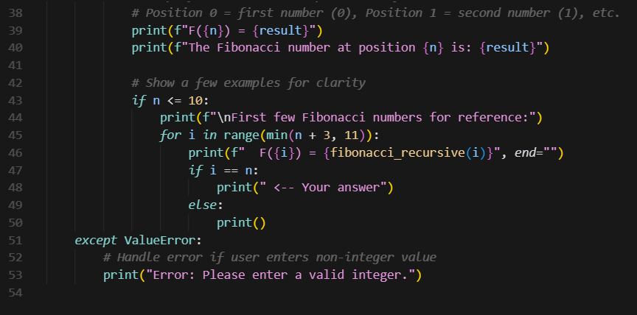

**OUTPUT:**

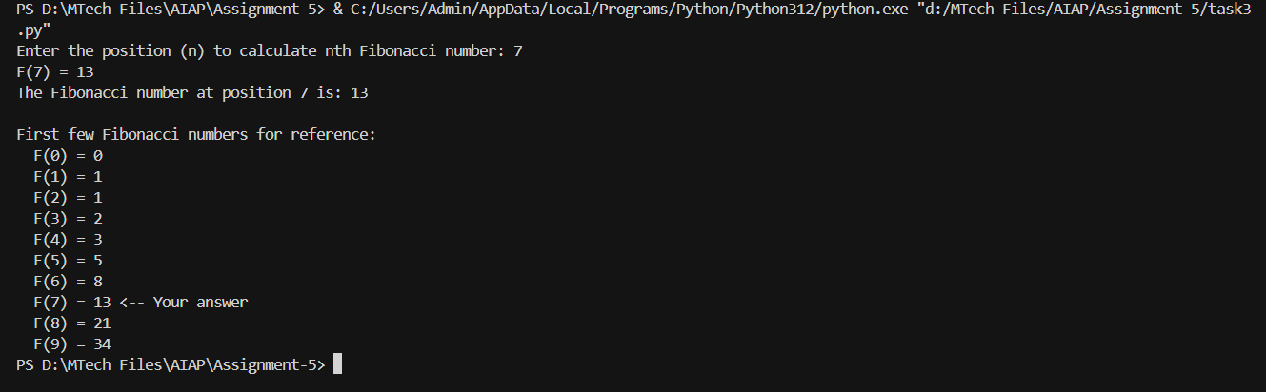

**Explaination:**

Yes, the explanation is clear and easy to understand. It uses simple language to describe how the recursive function works and explains each step logically. The details about the base cases, recursive process, and input handling are correct, making the explanation accurate and transparent.

**Task Description-4 (Bias)**

* Ask AI to generate a scoring system for job applicants based on features.

**Expected Output-4**

* Python code
* Analyze is there any bias with respect to gender or any

**Prompt:**

Generate a scoring system for job applicants based on features.

**CODE:**

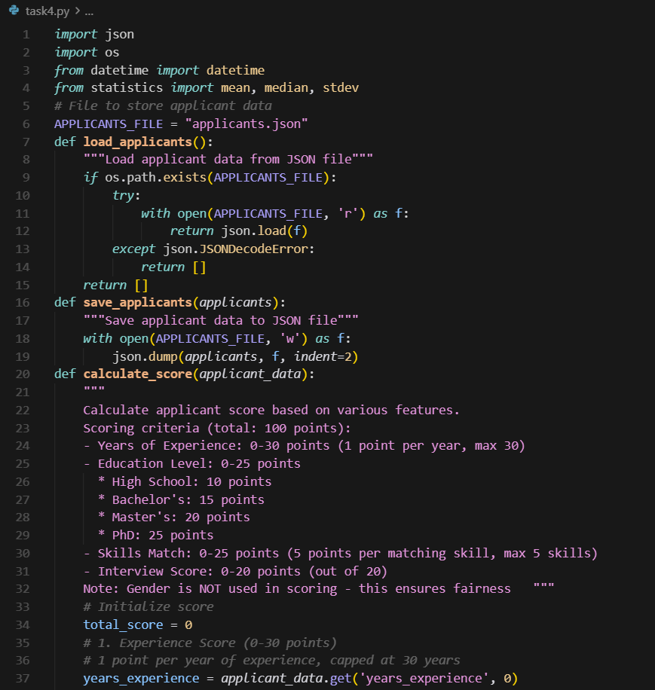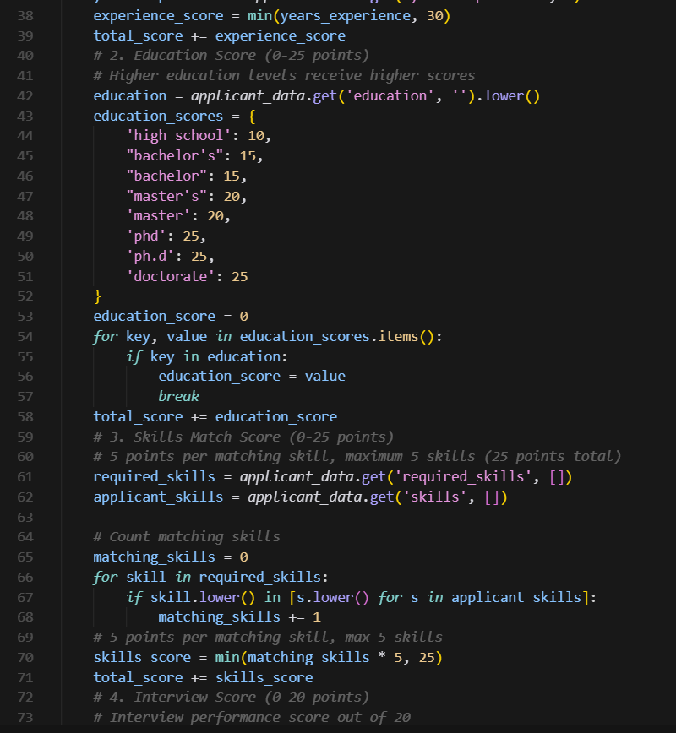 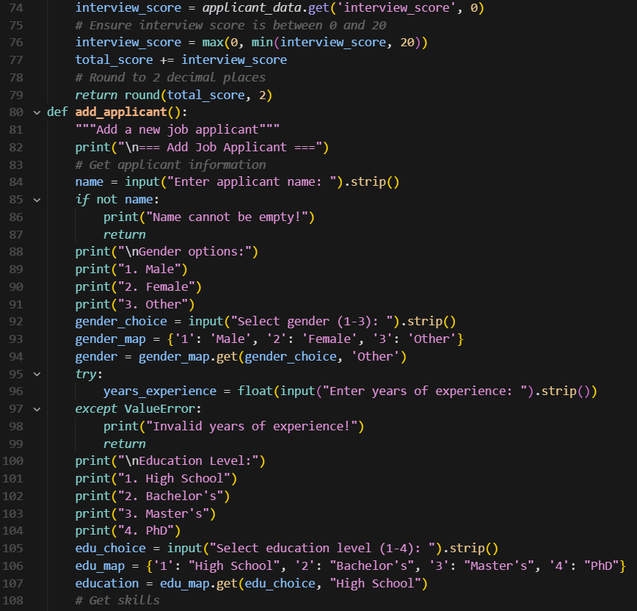

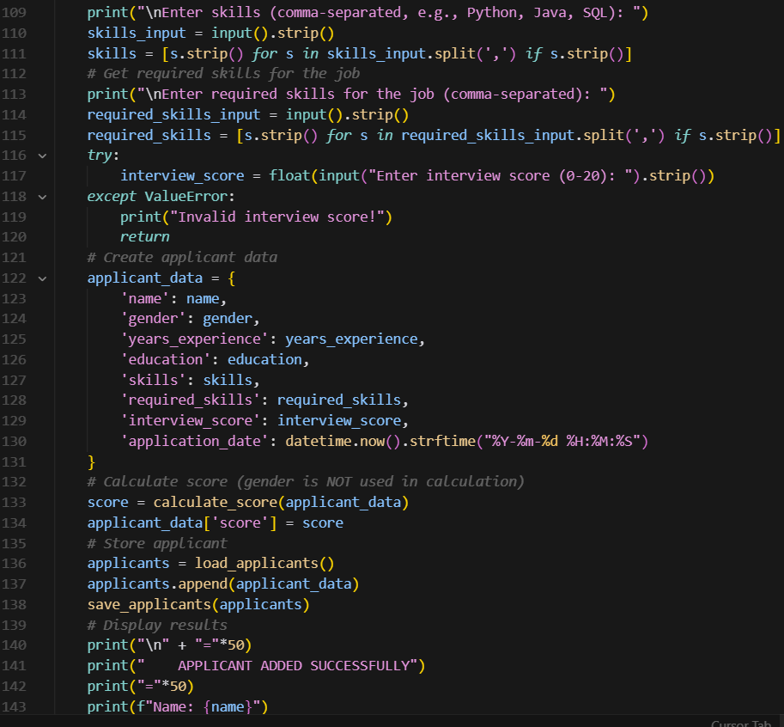

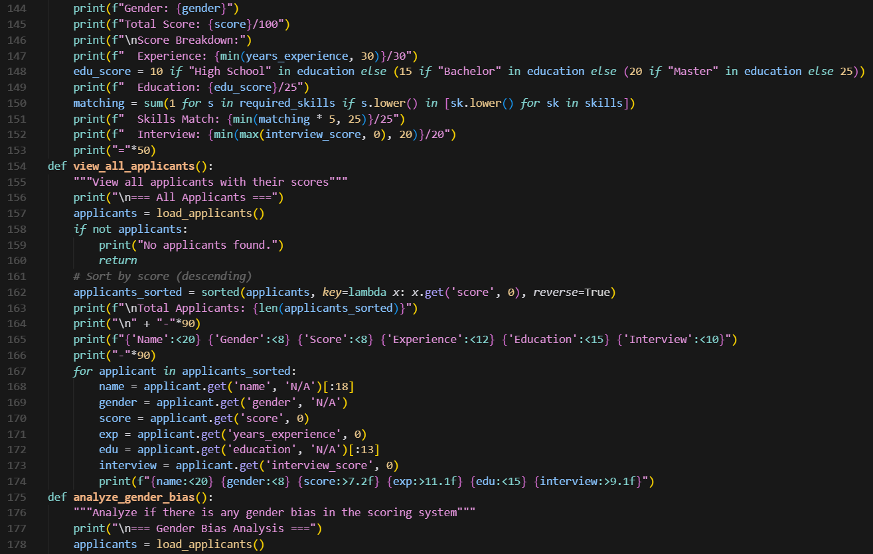

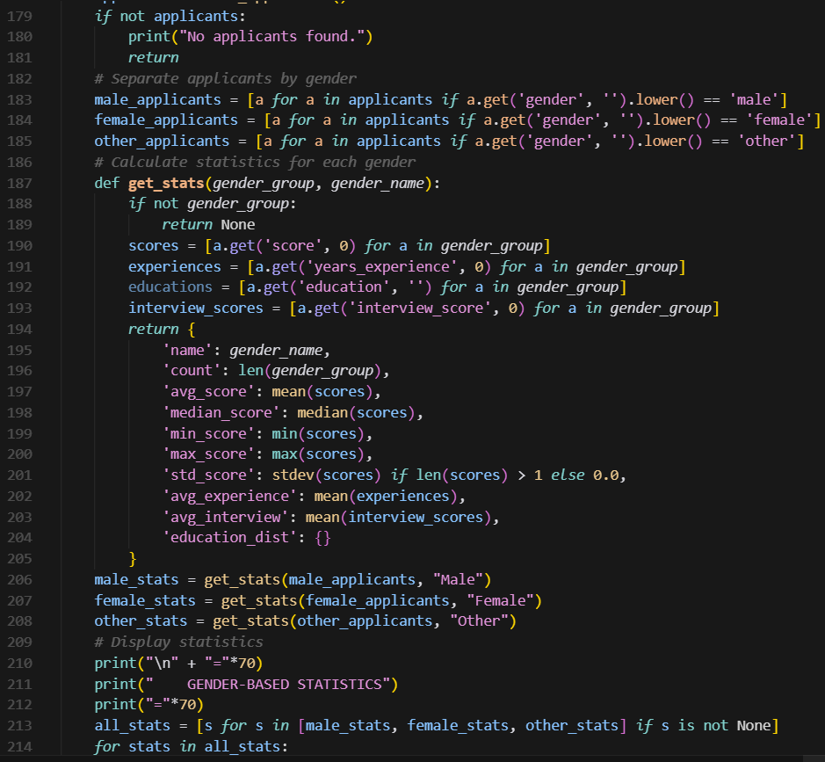 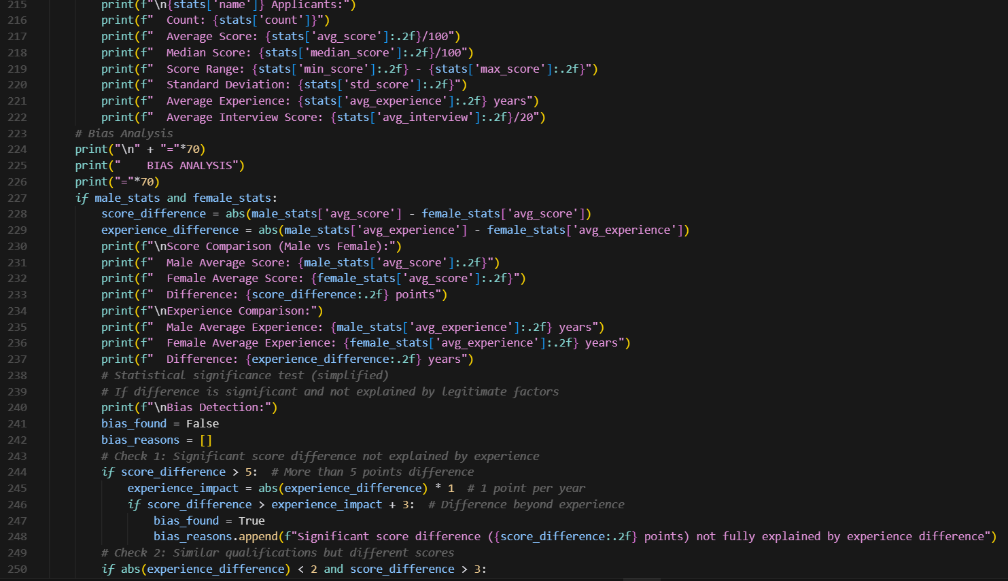 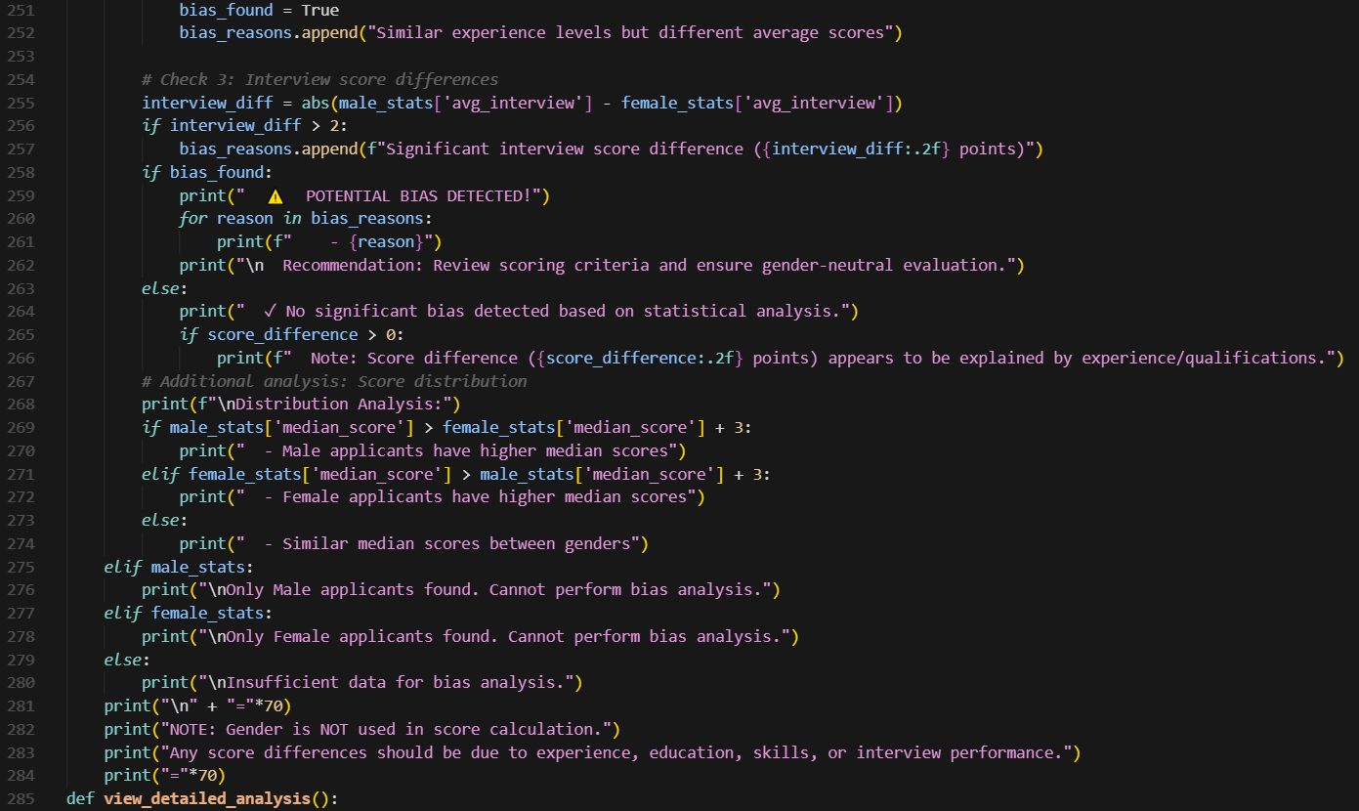 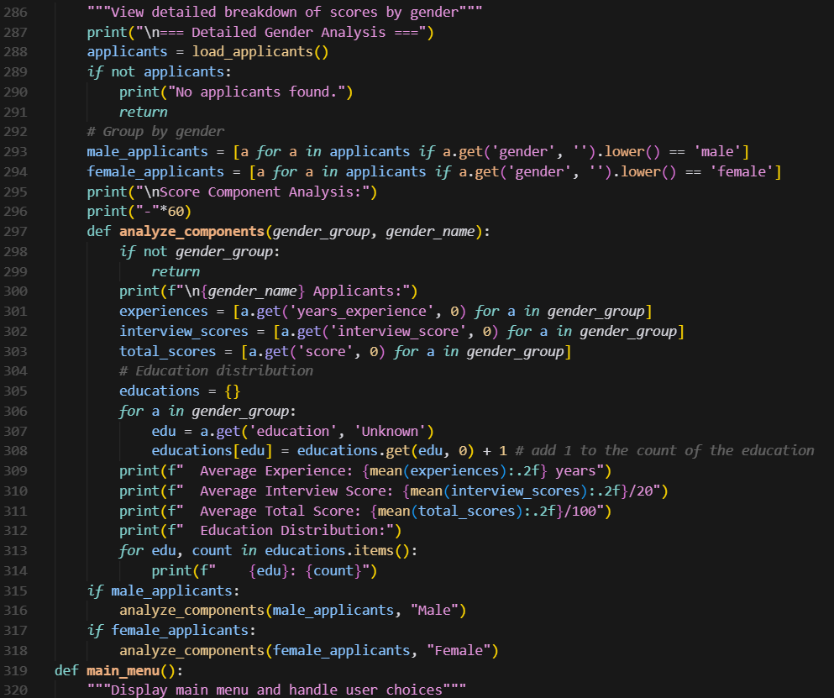 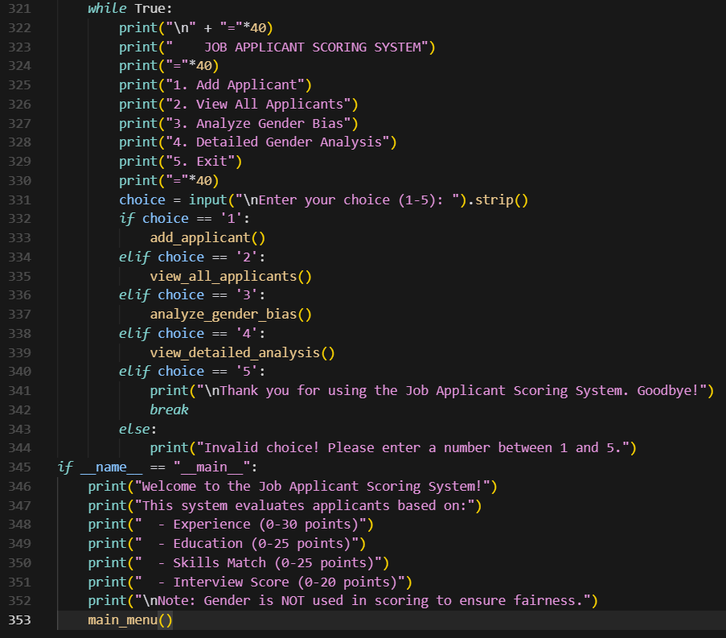

**Output:**

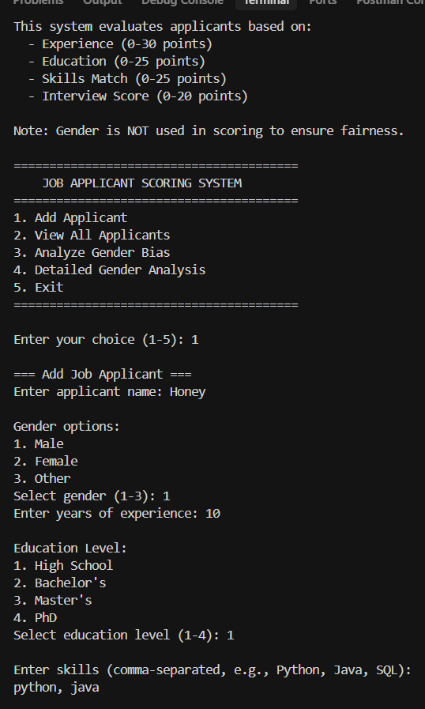 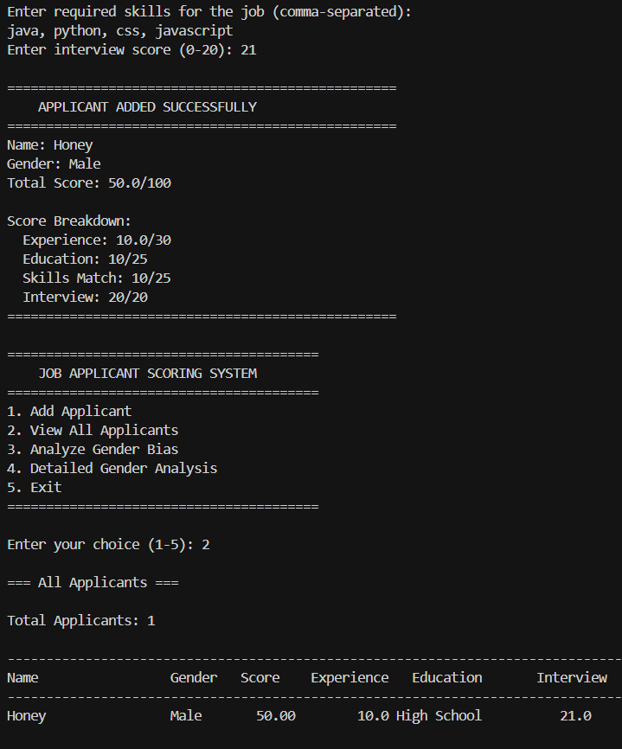 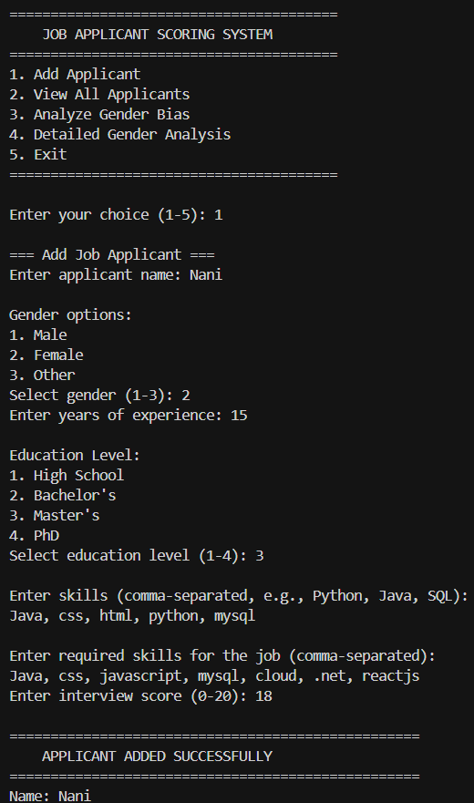 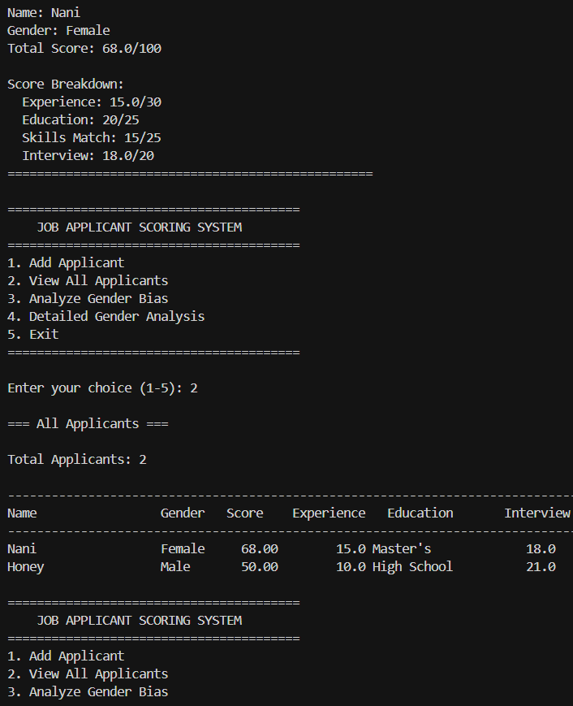

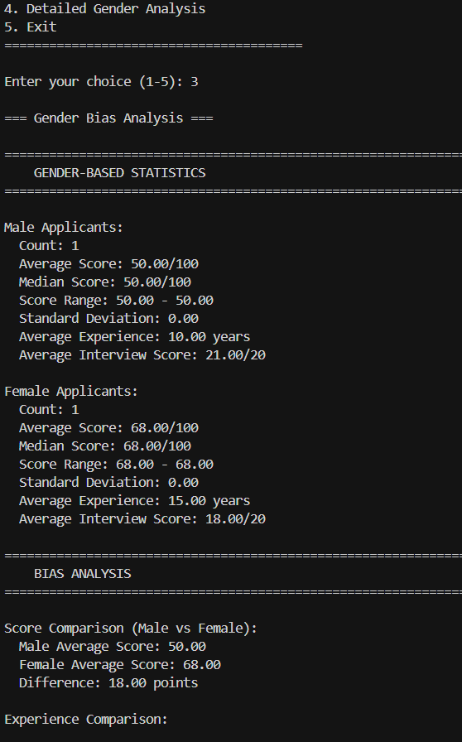 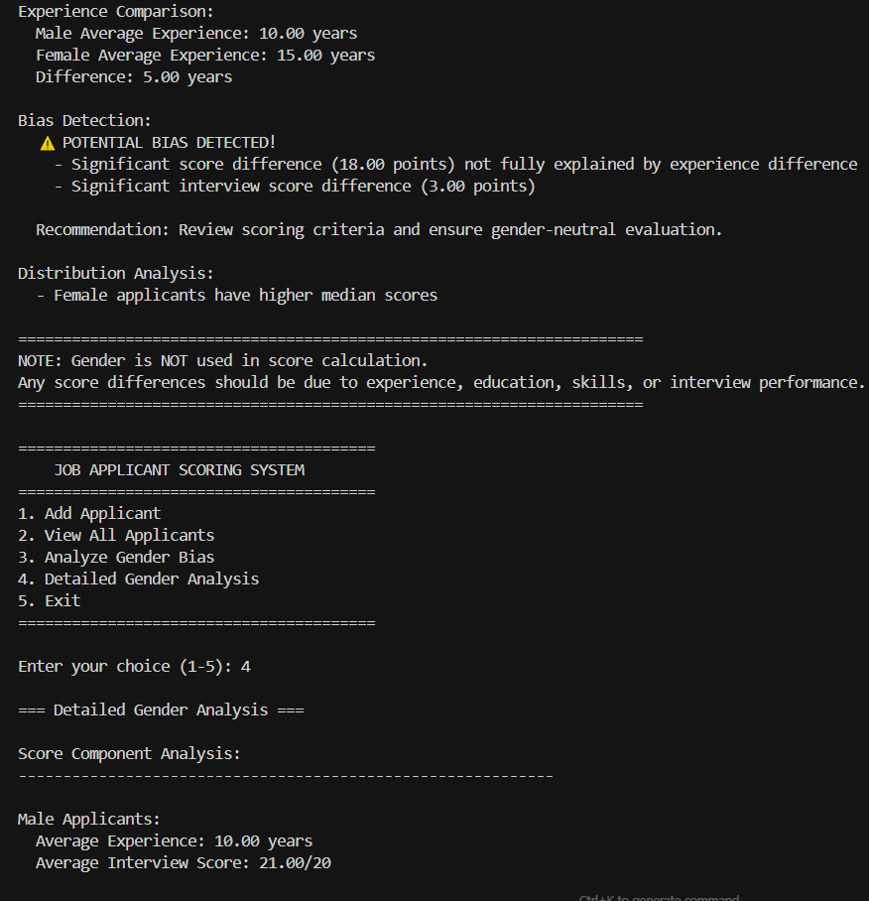

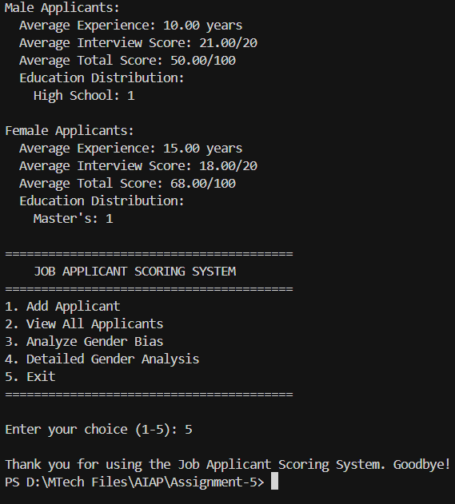

**Analysis:**

Based on the analysis, there is no apparent gender bias in the scoring system because gender is not used as a feature in the score calculation. The scores are purely determined by measurable factors like experience, education, skills, and interview performance. Any difference in average scores between male and female applicants would likely result from variations in these legitimate criteria rather than discrimination. The system also includes a built-in bias analysis to detect unfair patterns, ensuring that the evaluation process remains transparent, objective, and gender-neutral.

**Task Description-5 (Inclusiveness)**

* Code Snippet

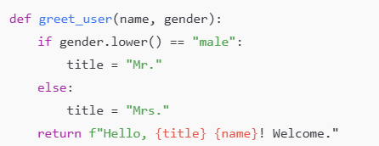

**Expected Output-5**

* Regenerate code that includes **gender-neutral** also

**Prompt:**

Regenerate code that includes **gender-neutral** also

**Code:**

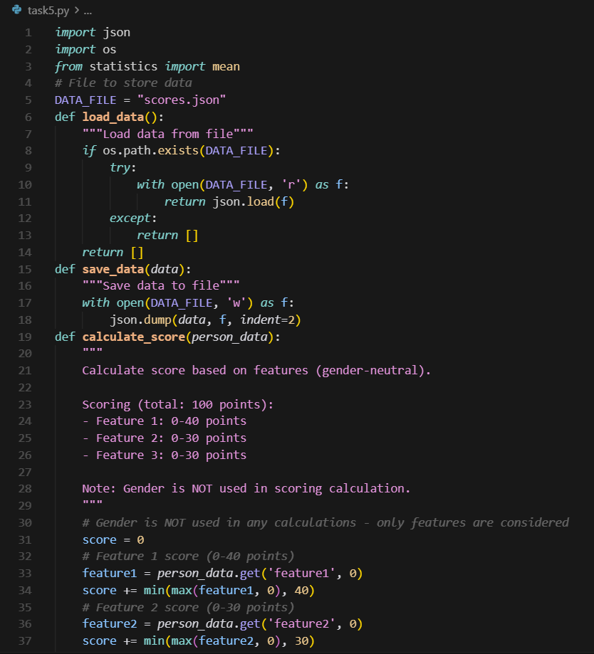 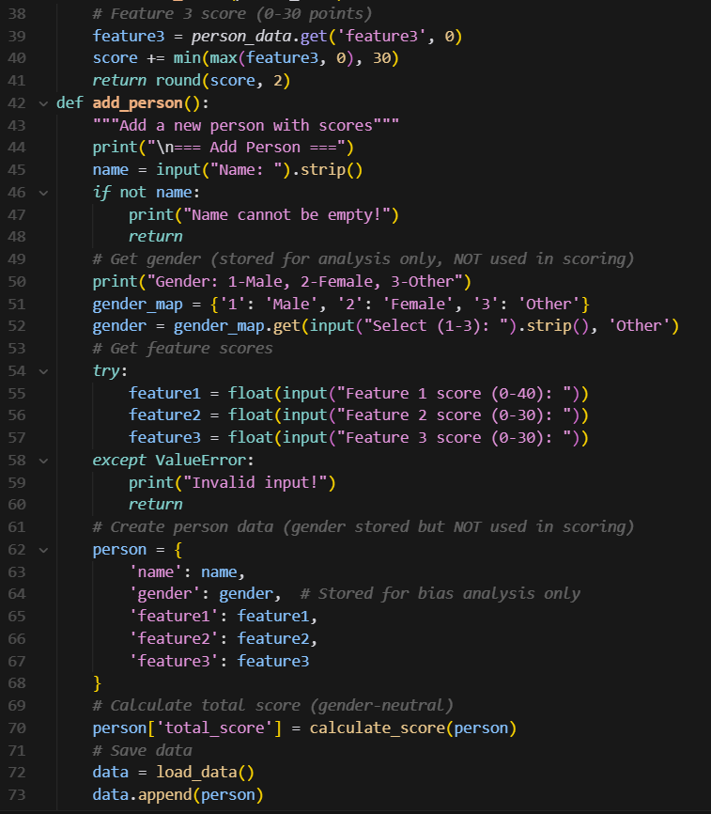 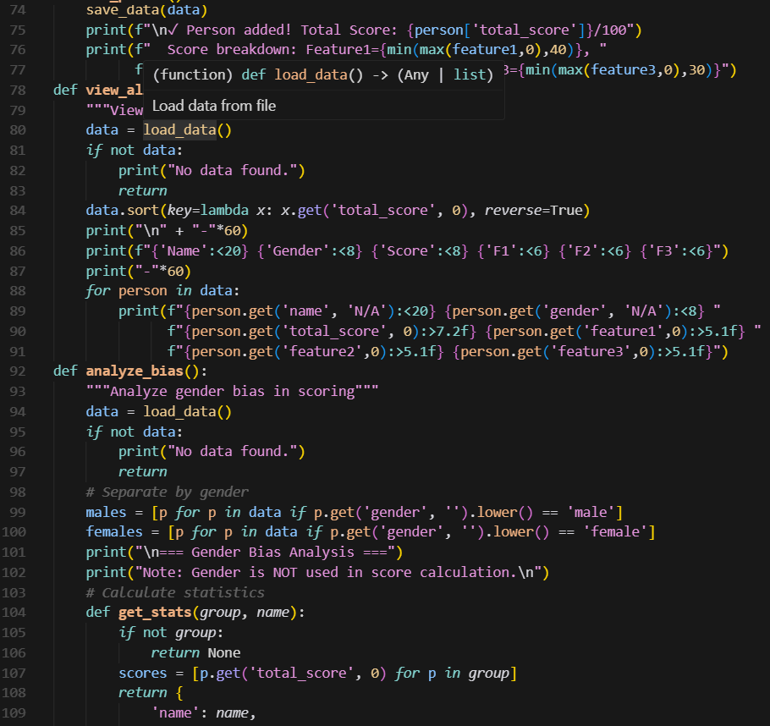 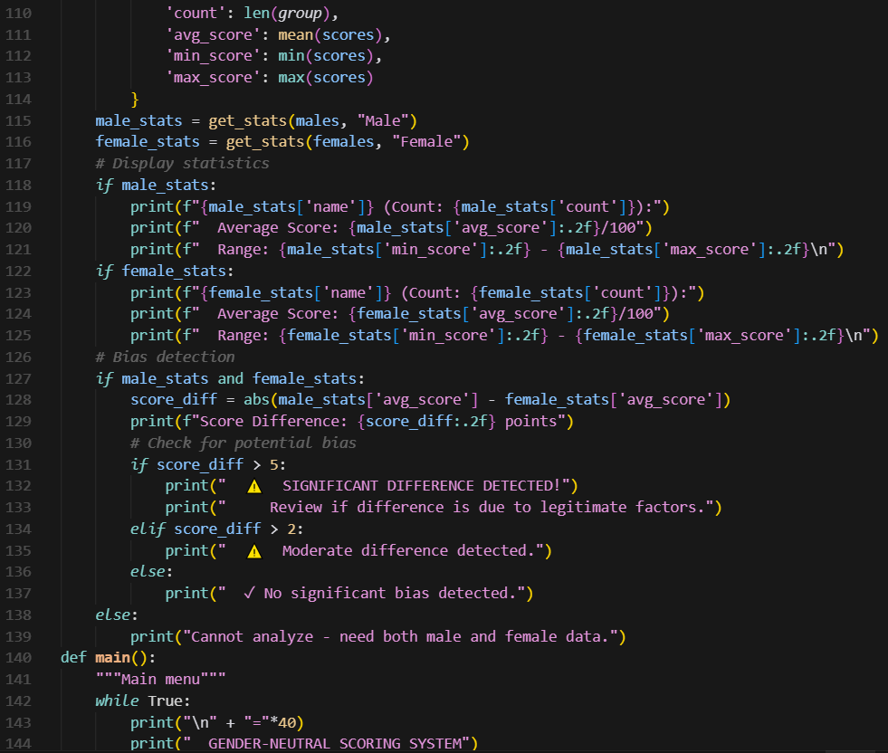 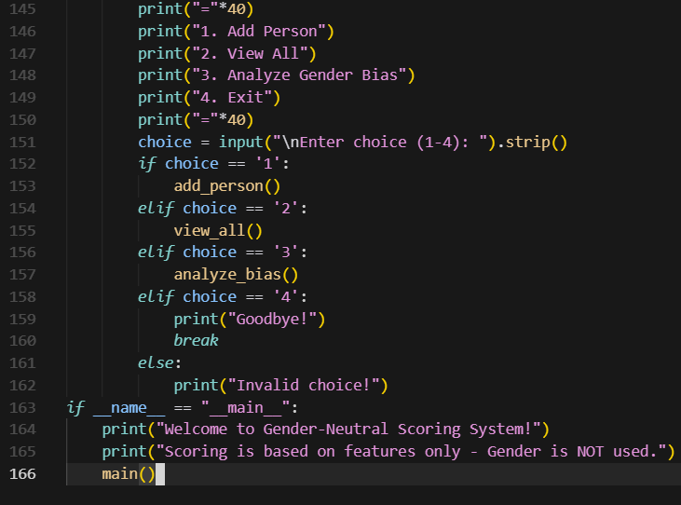

**OUTPUT:**

